Juniors for seniors – active aging
3rd Event Köszeg, August 26 – 29, 2021
Good practises in our town – Susice, Czech Republic - projects run by the Primary School
- Computers help us
The project is intended for primary school pupils and seniors, mostly the pupils’ family members are involved. Participants complete two courses during a school year - in the autumn and in the spring and get acquainted with the practical use of computers (internet, websites, e-mail, digital photography, safe use of the Internet). The pupils teach the seniors and vice versa.
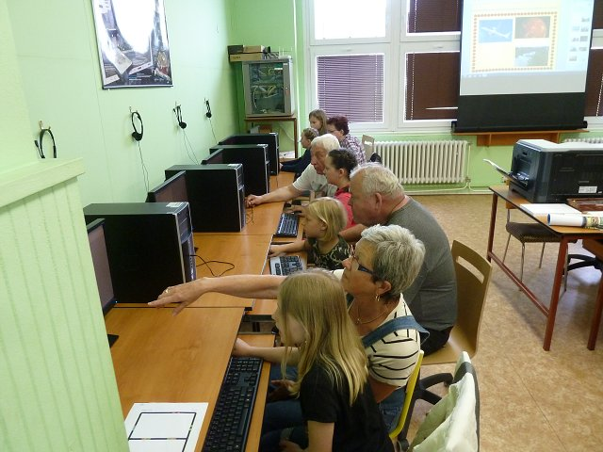
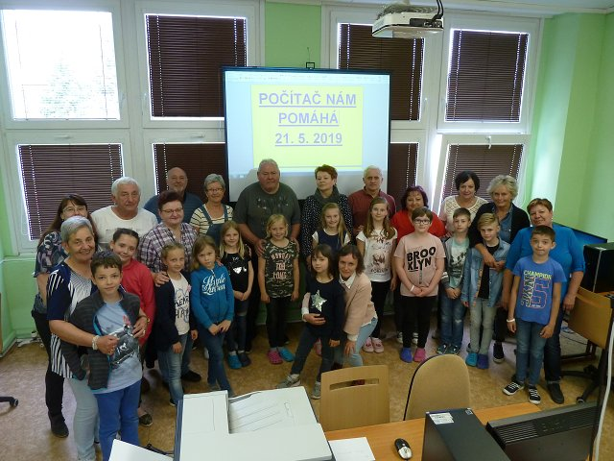
- What are bridges over the river for? - To get closer to each other.
Meeting generations at board games – pupils regularly come to see old people in the local seniors’ homes to play board games. The highlight of the meetings is the tournament in mixed teams in the most popular game “Sorry, don’t be angry” (called LUDO). In return, seniors teach children some skills in handicrafts (crochet, knitting) and together they make small gifts. The project helps mutual communication between generations, teaches children ethical education, tolerance and respect for old age.
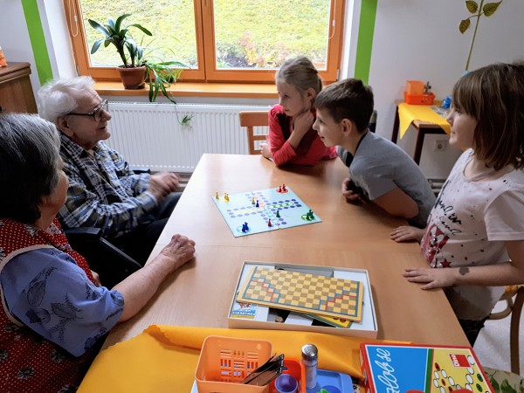
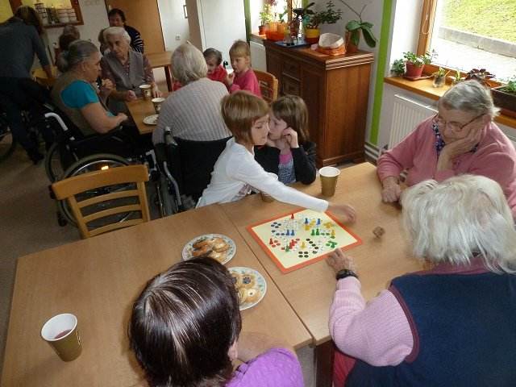
These are financially supported by the municipal authority every year.
- In addition to the projects mentioned above our school children make short drama performances for seniors on the celebrations of St. Nicholas, Christmas or Easter.
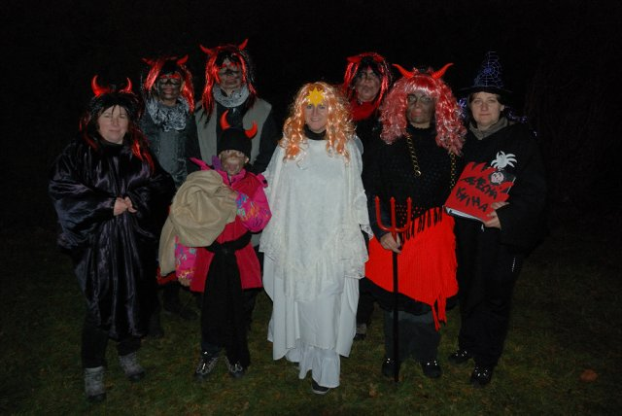

- Music for seniors - every other year, a festival of children's and youth choirs is held in Susice, which also includes concerts in the seniors’ homes.

Unfortunately, due to the pandemic situation, these events did not take place last school year. We really hope that the situation will improve soon so that these projects can continue.

